[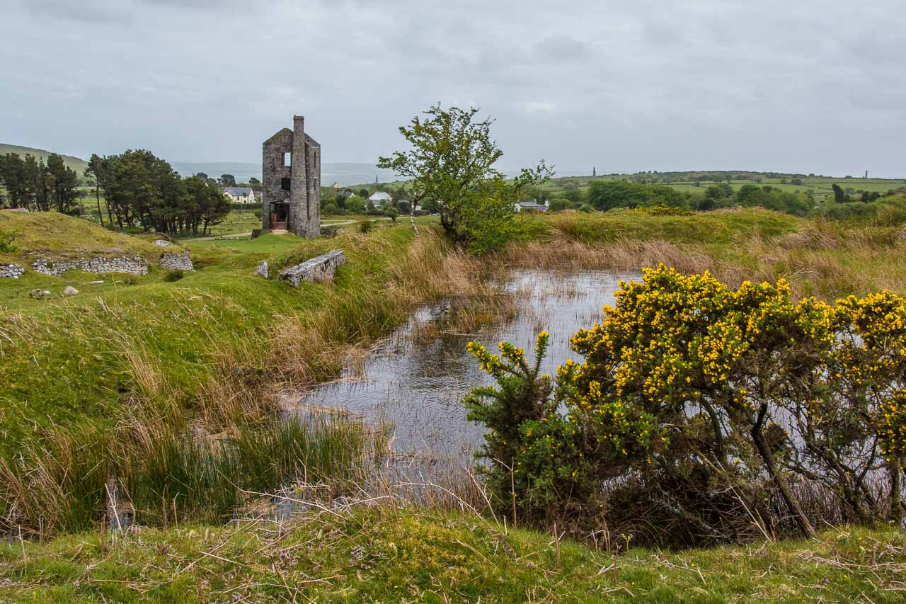](https://www.google.com/url?sa=i&url=https%3A%2F%2Fwww.moosearoundtheworld.de%2Fwasserfaelle-und-moore-dartmoor-national-park-bodmin-moor%2F&psig=AOvVaw3IyTyRTdfIN0nNl755xpfR&ust=1583793468593000&source=images&cd=vfe&ved=0CAIQjRxqFwoTCKCgysr4i-gCFQAAAAAdAAAAABAE)

[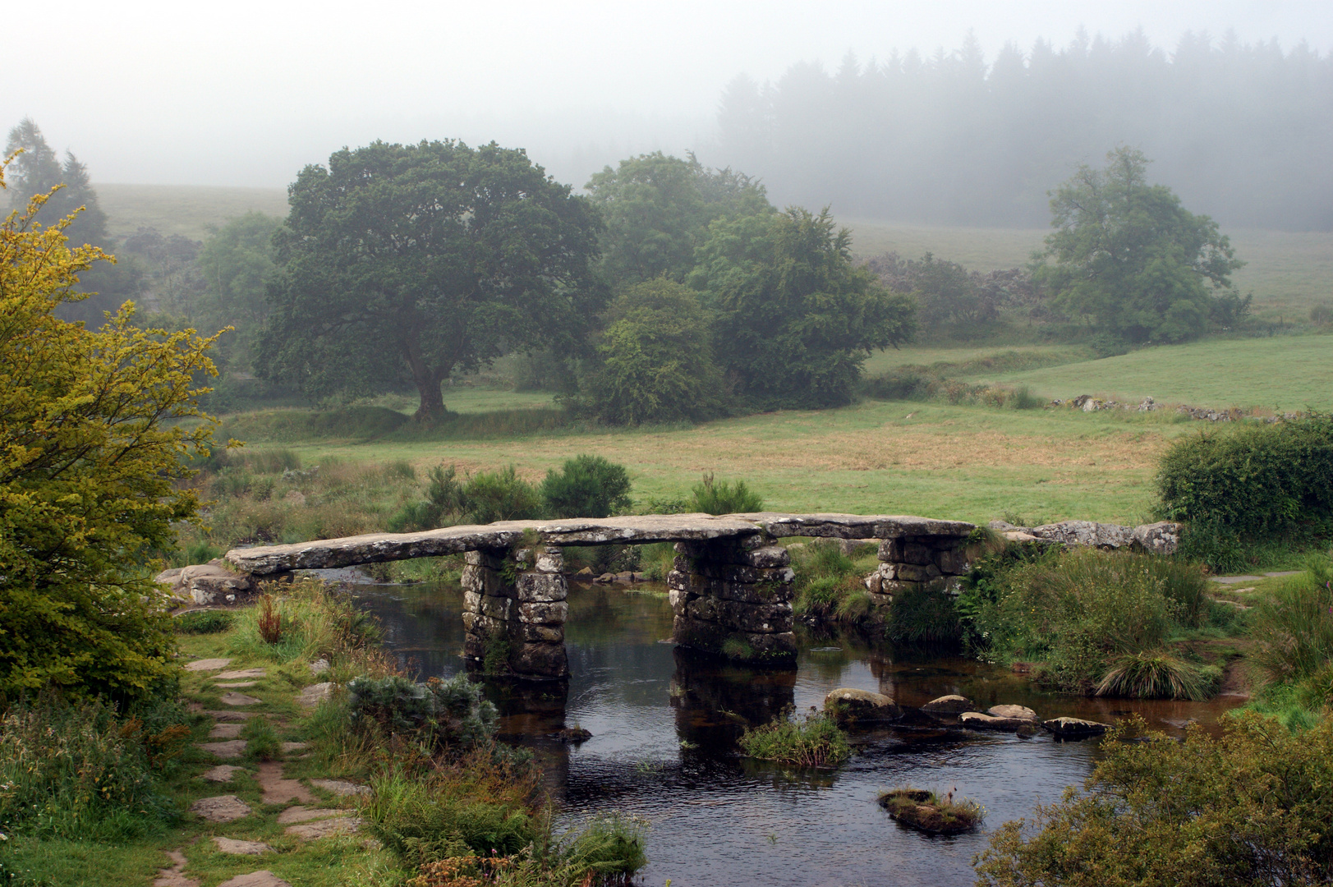](https://www.google.com/url?sa=i&url=https%3A%2F%2Fwww.fotocommunity.de%2Fphoto%2Fdartmoor-bruecke-aylinkay%2F27880435&psig=AOvVaw3IyTyRTdfIN0nNl755xpfR&ust=1583793468593000&source=images&cd=vfe&ved=0CAIQjRxqFwoTCKCgysr4i-gCFQAAAAAdAAAAABAK)

[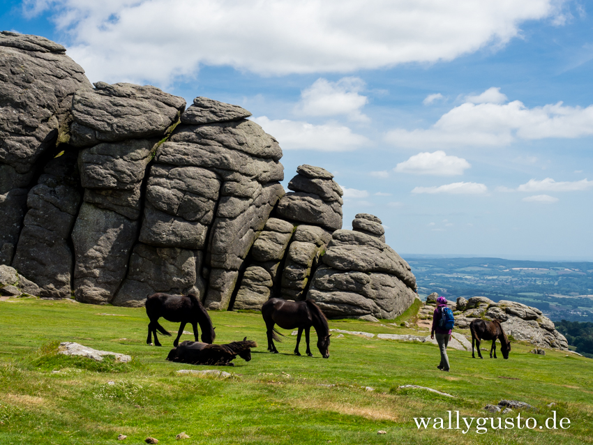](https://www.google.com/url?sa=i&url=https%3A%2F%2Fwallygusto.de%2F2019%2F01%2F14%2Fdartmoor-nationalpark-ein-roadtrip-durch-suedengland-3%2F&psig=AOvVaw3IyTyRTdfIN0nNl755xpfR&ust=1583793468593000&source=images&cd=vfe&ved=0CAIQjRxqFwoTCKCgysr4i-gCFQAAAAAdAAAAABAQ)

[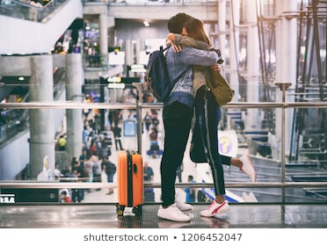](https://www.google.com/url?sa=i&url=https%3A%2F%2Fwww.shutterstock.com%2Fsearch%2Fpaar%2Bflughafen%3Fsection%3D1%26searchterm%3Dpaar%2520flughafen%26sort%3Dpopular%26safe%3Dfalse%26search_source%3Dbase_related_searches%26language%3Dde%26saveFiltersLink%3Dtrue&psig=AOvVaw3sN9c8Ysivw1ah5jdZCMgK&ust=1583793704101000&source=images&cd=vfe&ved=0CAIQjRxqFwoTCPi7-rr5i-gCFQAAAAAdAAAAABAE)

[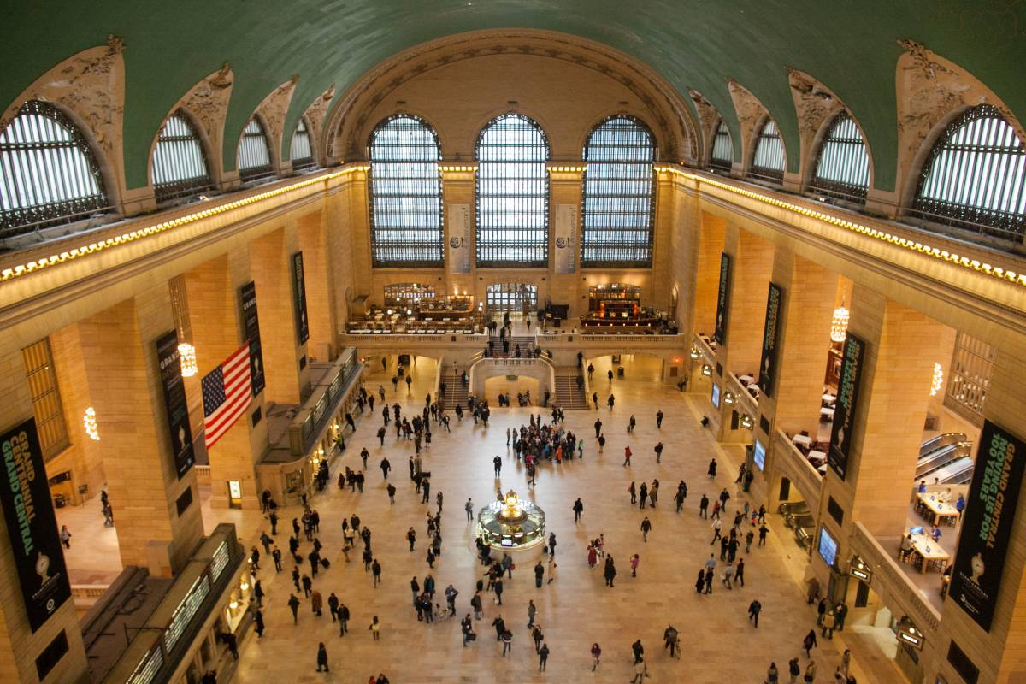](https://www.google.com/url?sa=i&url=https%3A%2F%2Fde.nycgo.com%2Farticles%2Fguide-to-grand-central-terminal&psig=AOvVaw3ZgQPRJVnLn4mRS2tTwWfv&ust=1583793856274000&source=images&cd=vfe&ved=0CAIQjRxqFwoTCIiVror6i-gCFQAAAAAdAAAAABAI)

[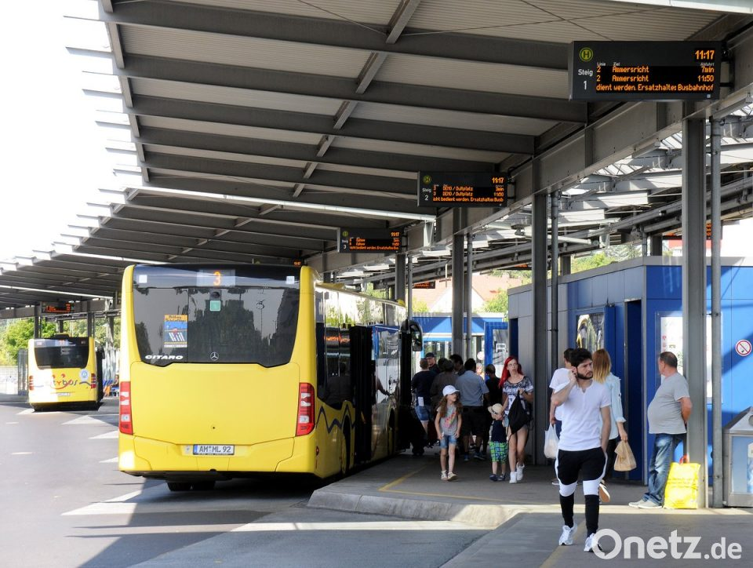](https://www.google.com/url?sa=i&url=https%3A%2F%2Fwww.onetz.de%2Famberg-in-der-oberpfalz%2Fpolitik%2Famberger-zob-soll-mit-taktilem-leitsystem-nachgeruestet-werden-busbahnhof-fuer-blinde-barrierefrei-d1770715.html&psig=AOvVaw1ly0KYU_JNAAiAAKetrRrT&ust=1583793945939000&source=images&cd=vfe&ved=0CAIQjRxqFwoTCOiUi676i-gCFQAAAAAdAAAAABAK)